

Practical No.: 7
Aim –
Perform DOM traversal and updates; develop a To-Do List application with add, edit, and delete features. Implement a registration form using JavaScript event handling and form validation.
Software/Tools Required –
VSCode, Chrome, HTML5, CSS3, Javascript (ES6)
Experiment Program Code –
index.html
<!DOCTYPE html>
<html lang="en">

<head>
<meta charset="UTF-8">
<meta name="viewport" content="width=device-width, initial-scale=1.0">

<title>My To-Do List</title>

<style>

* {
margin: 0;
padding: 0;
box-sizing: border-box;
}

body {
min-height: 100vh;
font-family: "Segoe UI", Arial, sans-serif;

display: flex;
justify-content: center;
align-items: center;

padding: 30px;

background:
radial-gradient(circle at top left, #f9d6e6, transparent 35%),
radial-gradient(circle at bottom right, #d9d3ff, transparent 40%),
linear-gradient(135deg, #fff8fc, #f3f0ff);
}

.container {
width: 100%;
max-width: 520px;

padding: 35px;

border-radius: 28px;

background: rgba(255, 255, 255, 0.88);

backdrop-filter: blur(12px);

box-shadow:
0 20px 60px rgba(105, 82, 140, 0.18);
}

/* Header */

.header {
text-align: center;
margin-bottom: 30px;
}

.icon {
width: 58px;
height: 58px;

margin: 0 auto 15px;

display: flex;
align-items: center;
justify-content: center;

border-radius: 18px;

font-size: 25px;

background:
linear-gradient(135deg, #c7b8ff, #f4b8d5);

box-shadow:
0 8px 20px rgba(170, 140, 200, 0.25);
}

.header h2 {
color: #4d4261;
font-size: 30px;
margin-bottom: 7px;
}

.header p {
color: #91869e;
font-size: 14px;
}

/* Input Area */

.input-area {
display: flex;
gap: 10px;
}

#taskInput {
flex: 1;

padding: 14px 16px;

border: 1.5px solid #e6dff0;

border-radius: 14px;

background: #fcfaff;

outline: none;

font-size: 14px;

transition: 0.3s;
}

#taskInput:focus {
border-color: #ae9bea;

box-shadow:
0 0 0 4px rgba(174, 155, 234, 0.15);
}

#addBtn {
padding: 12px 20px;

border: none;
border-radius: 14px;

cursor: pointer;

color: white;

font-size: 14px;
font-weight: 600;

background:
linear-gradient(135deg, #9b8bd7, #d98eb5);

box-shadow:
0 8px 18px rgba(180, 130, 180, 0.25);

transition: 0.3s;
}

#addBtn:hover {
transform: translateY(-2px);

box-shadow:
0 12px 22px rgba(180, 130, 180, 0.3);
}

/* Tasks Heading */

.task-title {
display: flex;
justify-content: space-between;
align-items: center;

margin: 28px 0 15px;
}

.task-title h3 {
color: #5c526b;
font-size: 16px;
}

.task-title span {
padding: 5px 11px;

border-radius: 20px;

background: #f2edff;

color: #927fca;

font-size: 12px;
}

/* Task List */

ul {
list-style: none;
}

li {
display: flex;
justify-content: space-between;
align-items: center;

margin-bottom: 12px;

padding: 14px 15px;

border-radius: 16px;

background:
linear-gradient(135deg, #ffffff, #faf7ff);

border: 1px solid #eee8f5;

box-shadow:
0 5px 15px rgba(80, 60, 110, 0.06);

animation: appear 0.35s ease;
}

li span {
flex: 1;

color: #5b5265;

font-size: 14px;

word-break: break-word;

padding-right: 10px;
}

/* Buttons */

.buttons {
display: flex;
gap: 7px;
}

.buttons button {
border: none;

padding: 7px 11px;

border-radius: 9px;

cursor: pointer;

color: white;

font-size: 12px;

transition: 0.25s;
}

.edit {
background:
linear-gradient(135deg, #f0ae72, #e990a7);
}

.delete {
background:
linear-gradient(135deg, #dc7c91, #c96078);
}

.buttons button:hover {
transform: translateY(-2px);
}

/* Footer */

.designer {
margin-top: 28px;
padding-top: 18px;

border-top: 1px solid #eee8f2;

text-align: center;

color: #aaa0b0;

font-size: 11px;

line-height: 1.8;
}

.designer strong {
color: #8d78b9;
}

/* Animation */

@keyframes appear {

from {
opacity: 0;
transform: translateY(10px);
}

to {
opacity: 1;
transform: translateY(0);
}

}

/* Mobile */

@media (max-width: 500px) {

.container {
padding: 28px 20px;
}

.input-area {
flex-direction: column;
}

#addBtn {
width: 100%;
}

li {
flex-direction: column;
align-items: flex-start;
}

.buttons {
margin-top: 5px;
}

}

</style>

</head>

<body>

<div class="container">

<div class="header">

<div class="icon">
✓
</div>

<h2>My To-Do List</h2>

<p>
Little tasks. Big progress. ✦
</p>

</div>

<div class="input-area">

<input
type="text"
id="taskInput"
placeholder="What would you like to do?"
>

<button id="addBtn">
+ Add
</button>

</div>

<div class="task-title">

<h3>
Today's Tasks
</h3>

<span>
Stay productive ✦
</span>

</div>

<ul id="taskList"></ul>

<div class="designer">

Designed by
<strong>Sanskruti Gorle</strong>

<br>

PRN:
<strong>24070521025</strong>

</div>

</div>

<!-- YOUR ORIGINAL JAVASCRIPT -->

<script>

const taskInput = document.getElementById('taskInput');
const addBtn = document.getElementById('addBtn');
const taskList = document.getElementById('taskList');

addBtn.addEventListener('click', function() {
let task = taskInput.value.trim();

if (task === ""){
alert("Please enter a task!");
return;
}

const li = document.createElement('li');
const span = document.createElement('span');
span.textContent = task;

const buttons = document.createElement('div');
buttons.className = 'buttons';

const editBtn = document.createElement('button');
editBtn.textContent = 'Edit';
editBtn.className = 'edit';

editBtn.addEventListener('click', function() {
let newTask = prompt("Edit your task:", span.textContent);
if (newTask !== null && newTask.trim() !== "") {
span.textContent = newTask;
}
});

const deleteBtn = document.createElement('button');
deleteBtn.textContent = 'Delete';
deleteBtn.className = 'delete';

deleteBtn.addEventListener('click', function() {
taskList.removeChild(li);
});

buttons.appendChild(editBtn);
buttons.appendChild(deleteBtn);

li.appendChild(span);
li.appendChild(buttons);
taskList.appendChild(li);

taskInput.value = "";
});

</script>

</body>

</html>

Output –
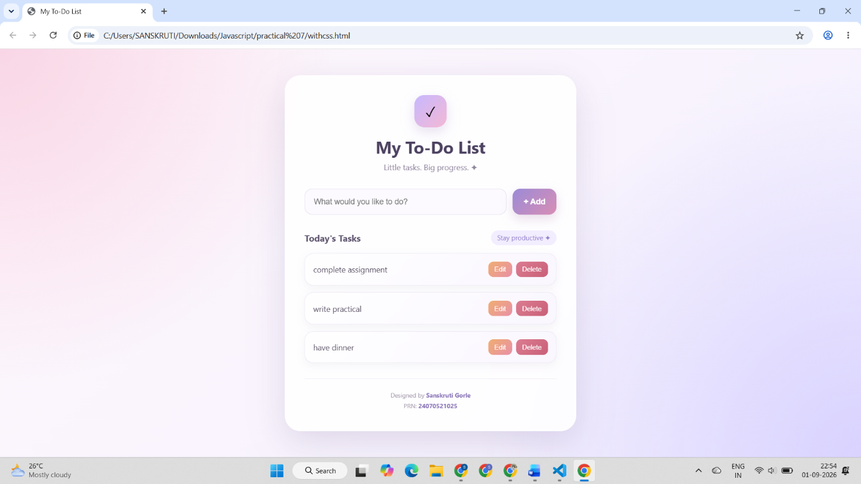

Case Study Title –
Implement a registration form using JavaScript event handling and form validation.
Case Study Program Code –
index.html
<!DOCTYPE html>
<html lang="en">
<head>
<meta charset="UTF-8">
<meta name="viewport" content="width=device-width, initial-scale=1.0">
<title>Create Account</title>

<style>
*{margin:0;padding:0;box-sizing:border-box}
body{
min-height:100vh;font-family:"Segoe UI",Arial,sans-serif;display:flex;
justify-content:center;align-items:center;padding:40px 20px;
background:radial-gradient(circle at 10% 15%,#dceefd 0,transparent 28%),
radial-gradient(circle at 90% 85%,#f8d8cf 0,transparent 30%),
linear-gradient(135deg,#eef6fc,#fff9f2)
}

.wrapper{
width:100%;max-width:1050px;min-height:690px;display:grid;
grid-template-columns:.9fr 1.3fr;border-radius:32px;overflow:hidden;
background:white;box-shadow:0 30px 80px rgba(24,49,83,.18)
}

.side{
position:relative;padding:55px 45px;overflow:hidden;color:white;
background:linear-gradient(160deg,#183153,#23466f)
}

.side::before,.side::after{
content:"";position:absolute;border-radius:50%;
background:rgba(184,216,243,.12)
}

.side::before{width:260px;height:260px;top:-100px;right:-90px}

.side::after{
width:230px;height:230px;bottom:-110px;left:-100px;
border:35px solid rgba(184,216,243,.1);background:none
}

.logo{
position:relative;z-index:2;width:52px;height:52px;display:flex;
align-items:center;justify-content:center;margin-bottom:45px;
border-radius:17px;color:#183153;background:#fff9f2;
font-size:22px;font-weight:bold
}

.side-content,.illustration{position:relative;z-index:2}
.side h1{font-size:38px;line-height:1.15;margin-bottom:18px}
.side p{color:rgba(255,255,255,.78);font-size:15px;line-height:1.7;max-width:290px}

.illustration{height:235px;margin-top:35px}

.desk,.desk-leg-left,.desk-leg-right,.laptop,.person,.plant,
.head,.hair,.body,.arm,.pot,.leaf{position:absolute}

.desk{
width:250px;height:14px;left:50%;bottom:25px;
transform:translateX(-50%);border-radius:20px;background:#b8d8f3
}

.desk-leg-left,.desk-leg-right{
width:10px;height:55px;bottom:-25px;border-radius:10px;background:#b8d8f3
}

.desk-leg-left{left:65px}
.desk-leg-right{right:65px}

.laptop{
width:120px;height:78px;left:50%;bottom:39px;
transform:translateX(-50%);border-radius:9px 9px 4px 4px;
background:#fff9f2;box-shadow:0 8px 20px rgba(0,0,0,.15)
}

.laptop::after{
content:"";position:absolute;width:145px;height:9px;left:50%;
bottom:-8px;transform:translateX(-50%);border-radius:10px;background:#d9eaf7
}

.screen{
position:absolute;width:95px;height:52px;top:12px;left:50%;
transform:translateX(-50%);border-radius:5px;
background:linear-gradient(135deg,#f28c7a,#f7b4a7)
}

.person{width:100px;height:150px;left:50px;bottom:39px}
.head{width:48px;height:48px;top:0;left:25px;border-radius:50%;background:#f6c4a8}
.hair{width:52px;height:28px;top:-2px;left:23px;border-radius:50px 50px 20px 20px;background:#392d2b}
.body{width:72px;height:80px;left:13px;top:45px;border-radius:35px 35px 15px 15px;background:#f28c7a}
.arm{width:18px;height:75px;right:2px;top:55px;border-radius:20px;background:#f6c4a8;transform:rotate(-30deg)}

.plant{right:20px;bottom:38px;width:55px;height:100px}
.pot{width:45px;height:35px;bottom:0;left:5px;border-radius:6px 6px 15px 15px;background:#f28c7a}
.leaf{width:28px;height:50px;border-radius:50px 0 50px 0;background:#8fc7a8}
.leaf1{left:7px;bottom:27px;transform:rotate(-30deg)}
.leaf2{right:5px;bottom:32px;transform:rotate(35deg)}
.leaf3{left:15px;bottom:48px;transform:rotate(5deg)}

.floating-star{
position:absolute;z-index:2;color:#f8c96a;font-size:25px;
animation:float 4s ease-in-out infinite
}

.star1{top:130px;right:50px}
.star2{bottom:145px;left:30px;font-size:18px;animation-delay:1s}

@keyframes float{
0%,100%{transform:translateY(0)}
50%{transform:translateY(-10px)}
}

.form-side{padding:48px 55px;background:#fff}
.form-header{margin-bottom:28px}
.form-header h2{color:#183153;font-size:29px;margin-bottom:8px}
.form-header p{color:#7d8791;font-size:14px}

.section-title{
display:flex;align-items:center;gap:9px;color:#55708b;
font-size:11px;font-weight:700;text-transform:uppercase;
letter-spacing:1.2px;margin:23px 0 15px
}

.section-title::after{
content:"";height:1px;flex:1;background:#e6edf2
}

.form-grid{display:grid;grid-template-columns:1fr 1fr;gap:15px}
.full{grid-column:1/-1}
.form-group{margin-bottom:3px}

label{
display:block;margin-bottom:7px;color:#34485b;
font-size:13px;font-weight:600
}

.required{color:#e57568}
.input-box{position:relative}

.input-icon{
position:absolute;left:14px;top:50%;transform:translateY(-50%);
color:#8aa1b5;font-size:14px;pointer-events:none
}

input,select{
width:100%;height:46px;border:1.5px solid #e2eaf0;
border-radius:11px;padding:0 13px 0 38px;background:#fbfcfd;
color:#24384b;font-size:13px;transition:.25s ease
}

select{padding-left:12px}
input::placeholder{color:#b0bbc4}

input:focus,select:focus{
outline:none;border-color:#719dc4;background:white;
box-shadow:0 0 0 4px rgba(113,157,196,.12)
}

.birthday{display:grid;grid-template-columns:.9fr 1.4fr 1fr;gap:9px}
.input-error{border-color:#d85c62!important;background:#fff7f7!important}
.input-success{border-color:#3a9364!important}

.error-text{
min-height:16px;margin-top:5px;color:#d85c62;
font-size:11px;font-weight:500
}

.terms{
display:flex;align-items:center;gap:10px;margin-top:20px;
padding:13px 15px;border-radius:11px;background:#f5f9fc;
border:1px solid #e7eef4
}

.terms input{
width:17px;height:17px;padding:0;accent-color:#23466f;cursor:pointer
}

.terms label{
margin:0;color:#647382;font-size:12px;font-weight:500;cursor:pointer
}

.terms-error{border-color:#d85c62!important;background:#fff7f7!important}

button{
width:100%;height:50px;margin-top:18px;border:none;border-radius:12px;
cursor:pointer;color:white;font-size:14px;font-weight:700;
background:linear-gradient(135deg,#183153,#28537e);
box-shadow:0 12px 25px rgba(24,49,83,.25);transition:.25s ease
}

button:hover{
transform:translateY(-2px);
box-shadow:0 16px 30px rgba(24,49,83,.32)
}

.designer{
text-align:center;margin-top:20px;color:#9aa7b3;font-size:11px
}

.designer strong{color:#55708b;font-weight:600}
.designer span{margin:0 6px;color:#f28c7a}

@media(max-width:850px){
.wrapper{grid-template-columns:1fr;max-width:650px}
.side{padding:40px 35px}
.illustration{display:none}
}

@media(max-width:550px){
.form-side{padding:35px 22px}
.side{padding:35px 25px}
.form-grid,.birthday{grid-template-columns:1fr}
.full{grid-column:auto}
.side h1{font-size:30px}
}
</style>
</head>

<body>

<div class="wrapper">

<div class="side">
<div class="logo">✦</div>

<div class="side-content">
<h1>Begin something<br>new today.</h1>
<p>Create your account and take the first step toward a better digital experience.</p>
</div>

<span class="floating-star star1">✦</span>
<span class="floating-star star2">✦</span>

<div class="illustration">
<div class="person">
<div class="head"></div>
<div class="hair"></div>
<div class="body"></div>
<div class="arm"></div>
</div>

<div class="laptop"><div class="screen"></div></div>
<div class="desk"></div>
<div class="desk-leg-left"></div>
<div class="desk-leg-right"></div>

<div class="plant">
<div class="leaf leaf1"></div>
<div class="leaf leaf2"></div>
<div class="leaf leaf3"></div>
<div class="pot"></div>
</div>
</div>
</div>

<div class="form-side">

<div class="form-header">
<h2>Create Account</h2>
<p>Fill in your information below</p>
</div>

<form id="registrationForm">

<div class="section-title">Personal Information</div>

<div class="form-grid">

<div class="form-group">
<label>First Name <span class="required">*</span></label>
<div class="input-box">
<span class="input-icon">◉</span>
<input type="text" id="firstname" placeholder="First name">
</div>
<p class="error-text" id="firstnameError"></p>
</div>

<div class="form-group">
<label>Last Name <span class="required">*</span></label>
<div class="input-box">
<span class="input-icon">◉</span>
<input type="text" id="lastname" placeholder="Last name">
</div>
<p class="error-text" id="lastnameError"></p>
</div>

<div class="form-group full">
<label>Birthday <span class="required">*</span></label>
<div class="birthday">
<select id="day"><option value="">Day</option></select>
<select id="month"><option value="">Month</option></select>
<select id="year"><option value="">Year</option></select>
</div>
<p class="error-text" id="birthdayError"></p>
</div>

</div>

<div class="section-title">Account Details</div>

<div class="form-grid">

<div class="form-group">
<label>Username <span class="required">*</span></label>
<div class="input-box">
<span class="input-icon">@</span>
<input type="text" id="username" placeholder="Username">
</div>
<p class="error-text" id="usernameError"></p>
</div>

<div class="form-group">
<label>E-mail <span class="required">*</span></label>
<div class="input-box">
<span class="input-icon">✉</span>
<input type="text" id="email" placeholder="name@email.com">
</div>
<p class="error-text" id="emailError"></p>
</div>

<div class="form-group full">
<label>Website <span class="required">*</span></label>
<div class="input-box">
<span class="input-icon">⌘</span>
<input type="text" id="website" placeholder="https://example.com">
</div>
<p class="error-text" id="websiteError"></p>
</div>

<div class="form-group">
<label>Password <span class="required">*</span></label>
<div class="input-box">
<span class="input-icon">●</span>
<input type="password" id="password" placeholder="Password">
</div>
<p class="error-text" id="passwordError"></p>
</div>

<div class="form-group">
<label>Re-password <span class="required">*</span></label>
<div class="input-box">
<span class="input-icon">●</span>
<input type="password" id="repassword" placeholder="Confirm password">
</div>
<p class="error-text" id="repasswordError"></p>
</div>

</div>

<div class="terms" id="termsBox">
<input type="checkbox" id="terms">
<label for="terms">I agree to the terms & conditions</label>
</div>

<p class="error-text" id="termsError"></p>

<button type="submit">Create My Account ✦</button>

</form>

<div class="designer">
Designed by <strong>Sanskruti Gorle</strong>
<span>•</span>
PRN: <strong>24070521025</strong>
</div>

</div>
</div>

<script>
const form=document.getElementById("registrationForm");
const firstname=document.getElementById("firstname");
const lastname=document.getElementById("lastname");
const username=document.getElementById("username");
const email=document.getElementById("email");
const website=document.getElementById("website");
const password=document.getElementById("password");
const repassword=document.getElementById("repassword");
const terms=document.getElementById("terms");
const termsBox=document.getElementById("termsBox");
const day=document.getElementById("day");
const month=document.getElementById("month");
const year=document.getElementById("year");

for(let i=1;i<=31;i++)
day.innerHTML+=`<option value="${i}">${i}</option>`;

const months=["January","February","March","April","May","June",
"July","August","September","October","November","December"];

months.forEach(m=>{
month.innerHTML+=`<option value="${m}">${m}</option>`;
});

for(let i=2026;i>=1950;i--)
year.innerHTML+=`<option value="${i}">${i}</option>`;

function showError(input,message){
input.classList.add("input-error");
input.classList.remove("input-success");
let error=document.getElementById(input.id+"Error");
if(error) error.textContent=message;
}

function showSuccess(input){
input.classList.remove("input-error");
input.classList.add("input-success");
let error=document.getElementById(input.id+"Error");
if(error) error.textContent="";
}

function validateRequired(input,message){
if(input.value.trim()===""){
showError(input,message);
return false;
}
showSuccess(input);
return true;
}

function validatePassword(){
let value=password.value;

if(value===""){
showError(password,"Password is required.");
return false;
}

if(value.length<8){
showError(password,"Password must contain at least 8 characters.");
return false;
}

if(!/[A-Z]/.test(value)){
showError(password,"Add at least one uppercase letter.");
return false;
}

if(!/[a-z]/.test(value)){
showError(password,"Add at least one lowercase letter.");
return false;
}

if(!/[!@#$%^&*(),.?":{}|<>]/.test(value)){
showError(password,"Add at least one special symbol.");
return false;
}

showSuccess(password);
return true;
}

function validateRepassword(){
if(repassword.value===""){
showError(repassword,"Please confirm your password.");
return false;
}

if(password.value!==repassword.value){
showError(repassword,"Passwords do not match.");
return false;
}

showSuccess(repassword);
return true;
}

function validateUsername(){
let value=username.value.trim();

if(value===""){
showError(username,"Username is required.");
return false;
}

if(value.length<4){
showError(username,"Username must contain at least 4 characters.");
return false;
}

showSuccess(username);
return true;
}

function validateEmail(){
let pattern=/^[^\s@]+@[^\s@]+\.[^\s@]+$/;

if(email.value.trim()===""){
showError(email,"Email address is required.");
return false;
}

if(!pattern.test(email.value.trim())){
showError(email,"Enter a valid email address.");
return false;
}

showSuccess(email);
return true;
}

function validateWebsite(){
let pattern=/^(https?:\/\/)?([\w-]+\.)+[\w-]+(\/.*)?$/;

if(website.value.trim()===""){
showError(website,"Website is required.");
return false;
}

if(!pattern.test(website.value.trim())){
showError(website,"Enter a valid website address.");
return false;
}

showSuccess(website);
return true;
}

function validateBirthday(){
let error=document.getElementById("birthdayError");

if(day.value===""||month.value===""||year.value===""){
[day,month,year].forEach(x=>x.classList.add("input-error"));
error.textContent="Please select your complete birthday.";
return false;
}

[day,month,year].forEach(x=>x.classList.remove("input-error"));
error.textContent="";
return true;
}

function validateTerms(){
let error=document.getElementById("termsError");

if(!terms.checked){
termsBox.classList.add("terms-error");
error.textContent="Please agree to the terms and conditions.";
return false;
}

termsBox.classList.remove("terms-error");
error.textContent="";
return true;
}

firstname.addEventListener("input",()=>validateRequired(firstname,"First name is required."));
lastname.addEventListener("input",()=>validateRequired(lastname,"Last name is required."));
username.addEventListener("input",validateUsername);
email.addEventListener("input",validateEmail);
website.addEventListener("input",validateWebsite);

password.addEventListener("input",()=>{
validatePassword();
if(repassword.value!=="") validateRepassword();
});

repassword.addEventListener("input",validateRepassword);

[day,month,year].forEach(x=>
x.addEventListener("change",validateBirthday)
);

terms.addEventListener("change",validateTerms);

form.addEventListener("submit",function(event){
event.preventDefault();

let valid=true;

if(!validateRequired(firstname,"First name is required.")) valid=false;
if(!validateRequired(lastname,"Last name is required.")) valid=false;
if(!validateBirthday()) valid=false;
if(!validateUsername()) valid=false;
if(!validateEmail()) valid=false;
if(!validateWebsite()) valid=false;
if(!validatePassword()) valid=false;
if(!validateRepassword()) valid=false;
if(!validateTerms()) valid=false;

if(valid){
alert("Account created successfully! 🎉");
form.reset();

form.querySelectorAll("input,select").forEach(input=>{
input.classList.remove("input-success","input-error");
});

document.querySelectorAll(".error-text").forEach(error=>{
error.textContent="";
});
}
});
</script>

</body>
</html>

Output –
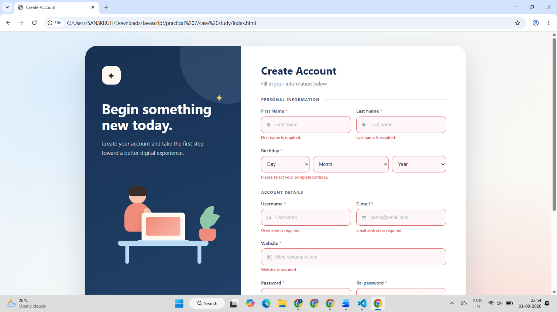
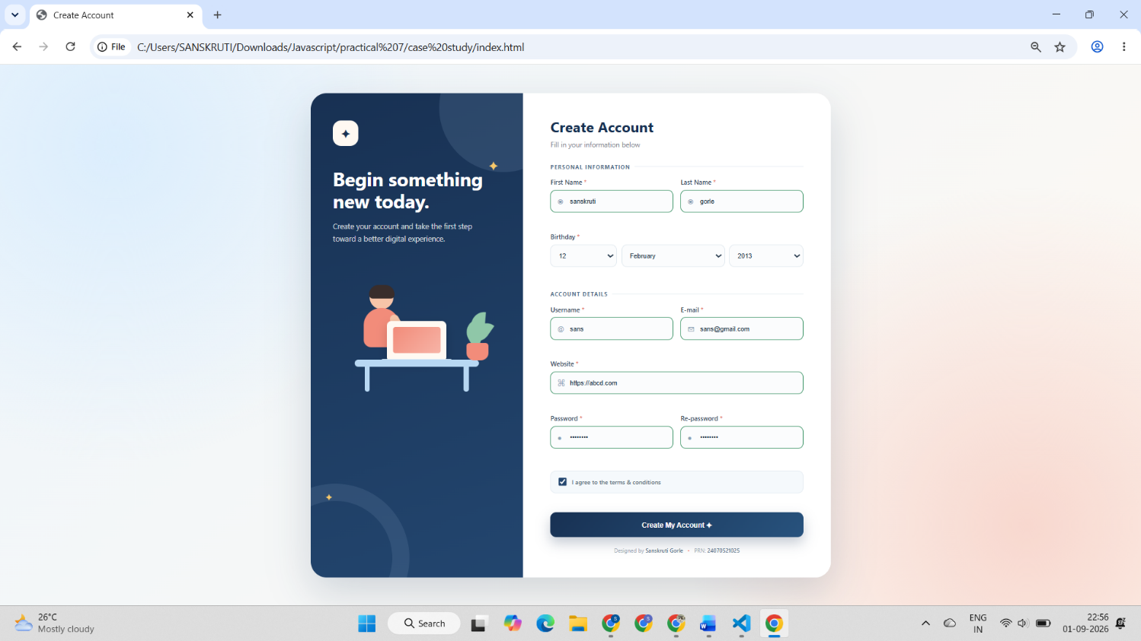
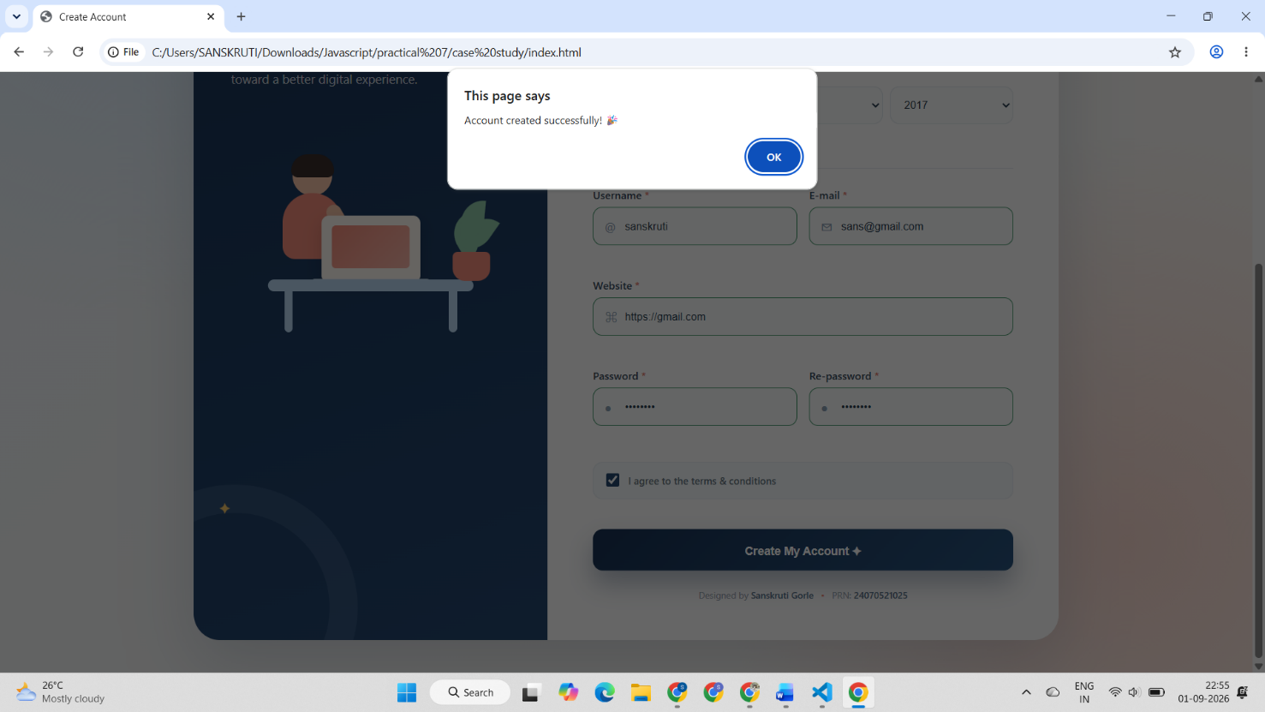
Conclusion –
The experiment was successfully performed to understand DOM traversal, manipulation, event handling, and form validation using JavaScript. A To-Do List application with Add, Edit, and Delete features was developed, and a registration form was implemented with dynamic validation and error handling.

